Table of contents

Table of contents 1
The theory behind MIMO 2
1.1 Introduction 2
1.2 Channel models and diversity 3
1.2.1 Space diversity in the channel 4
1.2.2 Polarization diversity 4
1.2.3 Fading and fading models 5
1.2.4 The Nakagami m fading channel 7
1.2.5 Estimation of the m-parameter 8
1.3 Channel capacity 10
1.3.1 Maximum capacity, if there is no CSI at the transmitter 11
1.3.2 STBC, a method to achieve close to maximum capacity 12
1.3.3 Maximum capacity, if the channel is known to the transmitter 14
1.3.4 Beamforming 17
1.4 Mutual coupling 18
1.5 A novel method to increase the capacity… 19
MIMO measurement setup 20
2.1 Hardware 20
2.2 Calibration 21
2.3 Measurement environment 22
2.3.1 Description of the measurement locations 24
2.4 Antenna array configurations 25
2.5 The retrodirective antenna measurements 26
Results of the measurements in a static channel 28
3.1 Line of sight measurement with a linear array with all vertical polarization 28
3.2 Line of sight linear array with two elements horizontally polarized 32
3.3 LOS circular array with all elements vertically polarized 35
3.4 NLOS linear array with all elements in vertical polarization. 37
3.5 LOS frequency sweep with linear array and vertical polarization. 39
3.6 NLOS frequency sweep with linear array and vertical polarization. 40
3.7 Conclusions of measurements in static channel 40
Results of the measurements in a non-static channel 41
3.8 LOS linear array and vertical polarization 41
3.9 NLOS linear array and vertical polarization 45
3.10 Conclusions of measurements in a non-static channel 48
3.11 Measurement with retrodirective antenna in LOS non-static channel 49
3.12 Measurement with retrodirective antenna in NLOS case in a static channel 52
3.13 Conclusion of measurements with retrodirective in a non-static channel 53
Conclusions of MIMO measurements 54
4.1 When is CSI most usefulness at the transmitter? 54
4.2 What are the effects of mutual coupling at the antenna arrays? 54
4.3 How useful are the Nakagami m distribution? 54
4.4 When can a retrodirective antenna be useful in a MIMO channel? 54
Appendix A 55
Acknowledgement 56
References 57

The theory behind MIMO

1.1 Introduction
In the never-ending search for increased capacity in a wireless communication channel it has been shown that by using an MIMO (Multiple Input Multiple Output) system architecture it is possible to increase that capacity substantially. Usually fading is considered as a problem in wireless communication but MIMO channels uses the fading to increase the capacity.

MIMO systems transmits different signals from each transmit element so that the receiving antenna array receives a superposition of all the transmitted signals. All signals are transmitted from all elements once and the receiver solves a linear equation system to demodulate the message. The idea is that since the receiver detects the same signal several times at different positions in space at least one position should not be in a fading dip.

If the transmitter have CSI (Channel State Information) then the transmitter can use the “Waterfilling technique” (see section 1.3.4) to optimize the power allocation between the antenna elements so that an optimal capacity is achieved.

When the CSI is supplied to the transmitter a decrease in spectral efficiency is unavoidable so therefore it is interesting to know in what cases it is important to have CSI and when the benefits are negligible. This will be answered after a series of measurements.

Consider two transmitting antennas where the first antenna is transmitting and the second does not. The electro-magnetic wave from the first antenna will induce a voltage in the other antenna and then the other antenna will also transmit a signal and so on, this is called “Mutual coupling”. The effects of Mutual coupling on the capacity will be investigated in this thesis.

The Rayleigh-distribution is a well-known estimation of the PDF (Probability Density Function) of the fading statistics in a radio channel. In this thesis another distribution will be used that is called the “Nakagami m distribution”. The Nakagami m distribution has different shapes depending on the m-value and for m=1 it equals the Rayleigh distribution. Two different ways to estimate the m-parameter is presented (see section 1.2.5) and by measurements it will be shown if the Nakagami m distribution is a good way to estimate the PDF of the fading statistics or not.

Since the MIMO system architecture uses the independent fading between different antenna-elements perhaps it could be possible to increase the independent fading by using some sort of mixer in the channel so that the channel doesn’t get stuck in a stat of low diversity gain. There will be some experiments made with a retrodirective antenna that should work as a mixer.

This thesis is divided into four chapters with the contents listed below:

- Explaining the theories that has been used in the thesis
- Explaining the measurement setup and the hardware that has been used.
- Presenting the results from the different measurements and making some conclusions.
- Answering the four questions: In which cases are CSI at the transmitter most useful? Can the effects of mutual coupling increase the capacity? How useful is the Nakagami m distribution and is it difficult to estimate the m parameter? Can a retrodirective antenna be used to increase the independency of the fading channel?

1.2 Channel models and diversity

In this section some assumptions will be made about the channel that makes it possible to calculate the capacity for the channel. The H matrix will be introduced, the H matrix represent the complex channel gain, which incorporates the fading influence of the channel. The H matrix will be normalized in a way that makes it possible to compare the capacity for the MIMO system with a SISO system.

Consider a communication link with n_{T} transmitting antennas and n_{R} receiving antennas. Some important assumptions are made:

•There is only a single user transmitting at any given time, so the received signal is corrupted by AWGN (Additive White Gaussian Noise) only.
•The communication is carried out in packets that are of shorter timespan then the coherence time of the channel. This means that the channel is constant during the transmission of a packet.
•The channel fading is frequency-flat. This means that the channel gain can be represented by a complex number. This also means that the transmission is very narrowband and the complex number, which represents the fading, is constant over the bandwidth.

All of these assumptions will be proven to be adequate by measurements later.

With these assumptions we can use this mathematical model

$r_{t}={\text{Hs}}_{t}+v_{t}$ (1)

Where r_{t}=${\left[r_{t}^{1}r_{t}^{2}\text{.}\text{.}\text{.}r_{t}^{n_{r}}\right]}^{T}$is the received signal at time instant t, s_{t} $={\left[s_{t}^{1},s_{t}^{2},\text{.}\text{.}\text{.},s_{t}^{n_{T}}\right]}^{T}$is the sent signal and v_{t} is AWGN with unit variance and uncorrelated between the n_{r} receiver antennas. Receiver antenna i receive a superposition of every sent messages from transmitter j, weighted by the channel response and some AWGN are added.

The n_{R}n_{T} transition matrix is made up of elements h_{i,j} as follows

$H=\left(\begin{matrix}h_{1,1} & \text{.}\text{.}\text{.} & h_{1,n_{T}} \\ \text{.}\text{.}\text{.} & \text{.}\text{.}\text{.}\text{.} & \text{.}\text{.}\text{.} \\ h_{n_{R},1} & \text{.}\text{.}\text{.} & h_{n_{R},n_{T}}\end{matrix}\right)$, (2)

where h_{i,j} denotes the complex channel coefficient between the j:th transmit antenna and the i:th receiver antenna.

When comparing systems of different sizes, we need to normalize the channel matrix. The channel matrix is normalized such that ${\left\|H\right\|}_{F}^{2}=n_{T}⋅n_{R}$, where ${\left\|⋅\right\|}_{F}^{2}$ represent the Frobenius norm. This normalization removes the influence of the variation in time and frequency but keeps the spatial characteristics, which is of interest here. Also the increased antenna gain due to the use of multiple antennas is not included in (13).

1.2.1 Space diversity in the channel
When the receiving antenna is moved relative to the transmitter there will be temporary local minimum in the amplitude of the incoming electromagnetic wave. This is called fading. This will of course happened twice every wavelength in the standing wave scenario. This effect can be reduced by using two receiving antennas at a distance of quarter of a wavelength apart from each other. The receiver then checks from which antenna it gets the strongest signal and uses that one. This is called space diversity.
Suppose a receiver has one antenna at point A in the Figure 1.1 below and one antenna at point B, it is obvious that the amplitude in the received signal from antenna B is much greater then the received signal from antenna A. It is also evident that there is a great advantage to be able to choose between these two antennas.

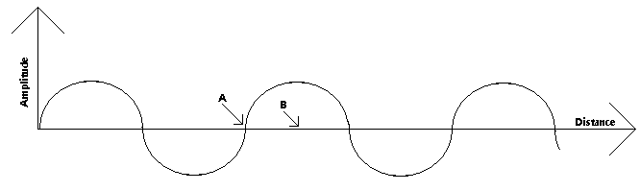
Figure 1.1. This figure shows that although point A and B are close to each other the received signal strength is very different. This is because of fading in the channel.

1.2.2 Polarization diversity
Even if the signal is sent with linear vertical polarization and the receiver has linear vertical polarization it is not evident that the incident signal at the Rx is of linear vertical polarization due to reflections in the channel. If the received signal is low it is often possible to receive a stronger signal by changing the polarization direction. This can be obtained by having two antennas with 90°-separated polarizations.

1.2.3 Fading and fading models

In this section the concept of fading will be explained and two different fading distributions, Rayleigh and Nakagami m will be introduced.

Consider a simple communication system with one transmitting and one receiving antenna, the fading in this system can be approximated by the so-called “Two ray model”. When the transmitting antenna transmit a signal the receiving antenna will receive a signal that comes directly from the transmitter and a short while later there will come another signal that has been reflected by something, perhaps the ground or a large building.

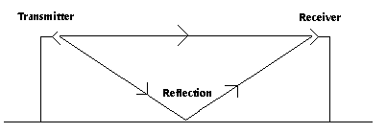
Figure 1.2 This figure shows that in the “Two ray model” the receiver will first receive a direct beam from the transmitter and a moment later it will also receive a reflected beam.

This is called multipath propagation and when many reflections exists this makes the nature of the mobile radio channel to be more easily described statistically. The ability to predict this fading behavior is very important to the receiver. If this is not possible there will not be an optimal reception of the signals at the receiver, which will be shown later. The received signal strength affected by channel fading, due to multipath propagation and shadow fading, due to large obstacles. The received signal is also affected by noise, both internal and external interference. In Figure 1.3 it is shown that globally the signal-strength decreases proportionally to $\frac{1}{4{πd}^{3\text{.}5}}$, and as$\frac{1}{4{πd}^{2}}$ in free space (not shown here). By closely examine the graph it can be seen that it varies more rapidly and this behavior comes from the quick fading and the multipath behavior of the channel. And in the receiver AWGN is added.

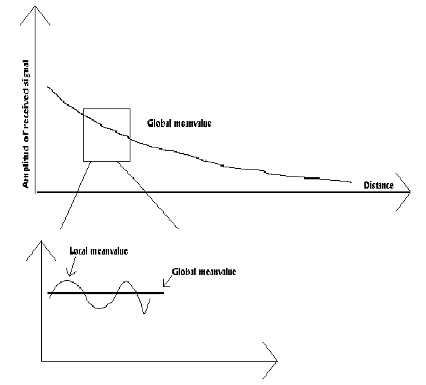

Figure 1.3 This figure shows that globally the signal strength decreases proportionally to 1/distance^{3.5}. By closely examine the graph it can be seen that it varies more rapidly because of fading and the multipath behavior of the channel.

The received signal can be expressed as eq. (1) $r_{t}={\text{Hs}}_{t}+v_{t}$ where H is the fading matrix and v is noise. Making a histogram of the received signal gives us an approximation of the PDF of the fading coefficients in the channel if the noise is negligible. There are several distributions used to model the fading statistics. The most commonly used distribution functions for the fading envelopes are Rice, Rayleigh and Nakagami-m. Rayleigh is a special case of Nakagami-m, when m equals one. The fading models are related to some physical conditions that determine what distribution that best describe the channel.

•The Rayleigh distribution assumes that there are a sufficiently large number of equal power multipath components with different and independent phase.
•The Nakagami one distribution equals the Rayleigh distribution above. It is a general observation that an increased m value corresponds to a lesser amount of fading and a stronger direct path.

1.2.4 The Nakagami m fading channel
Extensive empirical measurement has confirmed the usefulness of Nakagami m distribution for modeling radio links [1], [2]. The probability density function of a Nakagami m fading channel is given by

$P_{R}(r)=\frac{2}{Γ(m)}{\left(\frac{m}{Ω}\right)}^{m}r^{2m−1}e^{−{\text{mr}}^{2}σ^{2}}$, $r≥0$ (3)

Where $Ω$is the second moment, i.e. $Ω$=$E\left[R^{2}\right]$, this means that if $Z=X+\text{iY}$ and $X\text{\sim }N\left(0,σ_{N}^{2}\right)$ and $Y\text{\sim }N\left(0,σ_{N}^{2}\right)$ then $Ω=2σ_{N}^{2}$. The m parameter, also known as the fading figure is defined as

$m=\frac{Ω^{2}}{E\left[{\left(R^{2}−Ω\right)}^{2}\right]}$$=\frac{{\left(E\left[R^{2}\right]\right)}^{2}}{\text{var}\left[R^{2}\right]}$ , $m≥12$ (4)

The Nakagami m distribution covers a wide range of fading conditions; when m=1/2, it is a one-sided Gaussian distribution and when m=1 it is a Rayleigh distribution. In the limit when m approaches infinity, the channel becomes static hence, an AWGN channel. And its corresponding PDF becomes an impulsive function located at $σ$. The kth moment of the Nakagami m distribution is given by

$μ_{k}=E\left[R^{k}\right]$=$\frac{Γ\left(m+k2\right)}{Γ\left(m\right)}{\left(\frac{Ω}{m}\right)}^{k2}$

Finally it can be said that there is a relationship between the m-parameter in Nakagami-m distribution and the K parameter in the Rice distribution if m>1. The Rice distribution is not used and will not be explained in this thesis.

$K=\frac{\sqrt{1−1m}}{1−\sqrt{1−1m}}$, iff $m>1$ (5)

1.2.5 Estimation of the m-parameter
In this section two different methods to calculate the m-parameter in the Nakagami m distribution will be introduced. The methods are the moment method and the maximum likelihood method.

It is proposed in [3] that it is possible to use the moment method to estimate the m parameter. The estimator is

$\overset{}{\underset{}{\overset{}{m_{1}}}=}\frac{{\overset{}{μ}}_{2}^{2}}{{\overset{}{μ}}_{4}−{\overset{}{μ}}_{2}^{2}}$ (6)

Where

${\overset{}{μ}}_{k}=\left(\frac{1}{N}\right)\sum_{i=1}^{N}{r_{i}^{k}}$, k=2 or 4 (7)

In [4] it is a suggested to use a maximum-likelihood (ML) estimation to obtain the ML-optimal-m value of the measured channel amplitude. Let $R_{1},R_{2},\text{.}\text{.}\text{.},R_{N}$ be random i.i.d. variables that corresponds to a Nakagami m fading channel. The log-likelihood function (LLF) of the independent multivariate Nakagami-m distribution based on $R_{1},R_{2},\text{.}\text{.}\text{.},R_{N}$ is given by

$\text{LLF}=\text{ln}\left[\prod_{i=1}^{N}{\frac{2}{Γ\left(m\right)}{\left(\frac{m}{Ω}\right)}^{m}r_{i}^{2m−1}e^{−\left({\text{mr}}_{i}^{2}Ω\right)}}\right]$=$N⋅\text{ln}\left[\frac{2}{Γ\left(m\right)}{\left(\frac{m}{Ω}\right)}^{m}\right]+\left(2m−1\right)\sum_{i=1}^{N}{\text{ln}r_{i}^{2}}−\frac{m}{Ω}\sum_{i=1}^{N}{r_{i}^{2}}$

Where {r_{i}, i = 1,2,…,N} are samples of {R_{i}, i=1,2,…,N}. Taking the derivative of the LLF with respect to m, and setting it equal to zero, we obtain

$−ϕ\left(m\right)+\text{ln}m=\frac{\frac{1}{m}\sum_{i=1}^{N}{r_{i}^{2}}}{Ω}−1+\text{ln}Ω−\frac{1}{N}\sum_{i=1}^{N}{\text{ln}r_{i}^{2}}$

Where $ϕ\left(\text{.}\text{.}\text{.}\right)$ is the psi function, also called the digamma function, defined in [3, p.258, eq 6.3.1] as $ϕ\left(m\right)=Γ'\left(m\right)Γ\left(m\right)$, where $Γ'\left(m\right)=\frac{∂Γ\left(m\right)}{∂m}$. The statistic for m in (4) requires knowledge of $σ^{2}$which is usually not known. Substitution of the unbiased maximum-likelihood estimators of $Ω$, $\overset{}{Ω}=\left(\frac{1}{N}\right)\sum_{i=1}^{N}{r_{i}^{2}}$, in (4) yields

$−ϕ\left(m\right)+\text{ln}m≈Δ$ (8)

Where the approximation in (6) becomes exact as N approaches infinity, and where

$Δ=\text{ln}\left[\frac{1}{N}\sum_{i=1}^{N}{r_{i}^{2}}\right]−\frac{1}{N}\sum_{i=1}^{N}{\text{ln}(r_{i}^{2})}$ (9)

The parameter $Δ$ is determined by the observed samples only and it is independent of m. The ML estimation of the m parameter requires solving the nonlinear equation (8), which does not lead to a closed-form solution for the estimator. An asymptotic expansion of the psi function $ϕ\left(z\right)$ is given as [3, p.259, eq 6.3.18]

$$ϕ\left(z\right)≈\text{ln}z−\frac{1}{2z}−\frac{1}{\text{12}z^{2}}+\frac{1}{\text{120}z^{4}}−\frac{1}{\text{252}z^{6}}+\text{.}\text{.}\text{.}$$

Using the second order approximation $ϕ\left(z\right)≈\text{ln}z−\frac{1}{2z}−\frac{1}{\text{12}z^{2}}$ in (8) and solving $\text{12}{Δm}^{2}−6m−1=0$ for m, we obtain

${\overset{}{m}}_{2}=\frac{6+\sqrt{\text{36}+\text{48}Δ}}{\text{24}Δ}$ (10)

as the ML-estimator for m. In eq(10) all negative solutions have been discarded since only positive m values are of interest.

It is stated in [4] that the $\underset{}{\overset{}{m_{1}}}$ works badly when the m-value is low but gets better with higher m-values but never gets as good as $\underset{}{\overset{}{m_{2}}}$. It should also be considered that $\underset{}{\overset{}{m_{2}}}$ leads to a more complicated implementation. In section 3.8 & 3.9 the two methods have been used to approximate the m-parameter for an experimental dataset.

1.3 Channel capacity

In this section a definition of the channel capacity is made and there is also a discussion about how the capacity varies with the number of transmitting and receiving antennas.

An interesting discussion on how many transmitting and receiving antennas one should use can be found in [5]. Using a singular value decomposition (SVD), the channel matrix H can be decomposed into a product of three matrices as follows

$H=U⋅S⋅V^{}$ (11)

Where U are a unitary matrix of dimension $n_{R}$$n_{R}$, V are also a unitary matrix of dimension $n_{T}$$n_{T}$ and S is a $n_{R}$$n_{T}$ matrix whose elements are all zero except for the diagonal where there will be min($n_{T}$,$n_{R}$) of the H matrix eigenvalues. The V* represents the complex conjugate transpose of the matrix V. The three matrices corresponds to three different steps

1, Projection into Tx eigenmodes
Each of the first min($n_{T}$,$n_{R}$) columns in V is a unit-norm vector corresponding to each of the transmit eigenmodes. The relative phases and amplitudes between transmit elements required to excite each eigenmode are described by each of these column vectors. The first min($n_{T}$, $n_{R}$) components of the vector V1 are therefore the projection of the transmit vector x into the transmit eigenvector subspace. When $n_{T}$>$n_{R}$, the remaining $n_{T}$-$n_{R}$ components belong to the subspace orthogonal to the transmit eigenvector subspace and cannot influence the received vector r.

2, Weighting by singular values
Each of the min($n_{T}$,$n_{R}$) components corresponding to the transmit eigenmodes are weighted by it’s associated singular value contained in the main diagonal of the matrix S.

3, Mapping into Rx eigenmodes
Each of the first min($n_{T}$,$n_{R}$) columns in U is a unit-norm vector corresponding to the mapping of each eigenmode in the receiving space. The remaining N-min($n_{T}$,$n_{R}$) vectors are not Rx eigenmodes because they cannot be excited by the transmitter.

The discussion above leads to some interesting conclusions:

•If $n_{T}$>$n_{R}$, some power is wasted on exciting a subspace orthogonal to the receiver. The receiver cannot interpret this subspace and it’s totally unnecessary. If the power is allocated uniformly over the transmitter there will be an average power loss of $\text{10}\text{Log}\left(\frac{n_{T}}{n_{R}}\right)\text{.}$
•If $n_{T}≤n_{R}$, there is no power loss. There will be $n_{R}−n_{T}$ dimensions in the receiver space, which are not excited by the receiver eigenvectors.

1.3.1 Maximum capacity, if there is no CSI at the transmitter
In this section the capacity for a MIMO channel will be defined. There will also be shown that by supplying the transmitter with channel state information (CSI) it is a possible to greatly increase the capacity

The channel is estimated in the receiver through to use of a short known transmitted training sequence.

For a one-antenna system one can apply the Shannon formula:

$C={\text{Log}}_{2}\left(1+SN\right)$ (12)

Where C is the channel and is measured in [Bits/(sec*Hz)], B is the bandwidth and S/N is the signal-to-noise ratio. This is the maximum rate the channel can give with arbitrary low probability of bit errors (allowing infinite coding delay). Hence, it is an upper limit on the practical achievable bit-rate. When one uses a MIMO system one have to use a generalized version of Shannon’s formula:

$C={\text{Log}}_{2}\left(\text{det}\left(I+\frac{ρ_{k}⋅{\text{HH}}^{}}{σ^{2}}\right)\right)$=$\sum_{k=1}^{n}{{\text{Log}}_{2}\left(1+\frac{ρ_{k}}{σ^{2}}λ_{k}\right)}$ (13)

Where H is the transition matrix and (*) denotes the complex conjugate transpose. $ρ_{k}$, k=1,2,…,n is the transmitted energy through channel ”mode” k with power gain $λ_{k}$. As a consequence of this

$\sum{ρ_{k}=P_{T}}$ (14)

where $P_{T}$ is the totally available power. $λ$ is also the eigenvalue to HH* where $λ_{1}>λ_{2}>\text{.}\text{.}\text{.}>λ_{n}$. And n is min[ n_{T} = number of transmitters, n_{R} = number of receivers].

There are two different power distribution cases that are of interest here:

• Uniform Input Power Channel (UIPC)
• Non-Uniform Input Power Channel (NIPC)

If the channel is unknown to the transmitter the most sensible choice is to use UIPC that is that all $ρ_{k}=P_{T}n$. On the other hand if the transmitter knows all $λ_{k}$ it is evident that it is possible to increase the capacity by sending more power to channels with larger $λ_{k}$, see water filling below. One can easily see that a large capacity hinges on the presence of a rich scattering environment, being directly related to the rank of the channel matrix.

1.3.2 STBC, a method to achieve close to maximum capacity
In this section a practical method to achieve the capacity in section 1.4.1 will be proposed and explained for a simple MISO (Multiple Input Single Output) system.

When there is no CSI available at the transmitter there are several different methods to achieve optimal capacity for a MISO system. Space-time block coding has received much attention lately and in this thesis the Alamouti scheme, which is a simple Space-time block code will be explained. STBC will not achieve optimal capacity for a MIMO system but are still a very promising approach. See [3] for a complete description.

Suppose that we have a communication system with $n_{T}=2$and $n_{R}=1$, that is two transmitting antennas and one receiving antenna. The Alamouti scheme consists of two steps.

•Encoding and transmitting
At every given time period two symbols are transmitted at the same time at the same frequency but from different antennas. The transmitted signal from antenna 0 is s₀ and the signal transmitted from antenna 1 is s₁. The next time slot $−s_{1}^{}$ is transmitted from antenna 0 and $s_{0}^{}$ is transmitted from antenna 1. The received signal is:

r₀ = $s_{0}∗h_{0}+s_{1}∗h_{1}+n_{0}$ (15a) r₁=$−s_{1}^{}∗h_{0}$ +$s_{0}^{}∗h_{1}+n_{1}$ (15b)

Where $h_{0},h_{1}∈\text{CN}\left(0,12\right)$ is the fading statistics of the channel between the receiver and transmitting antenna 0 and 1 respectively. $n_{0},n_{1}∈\text{CN}\left(0,1\right)$ are AWGN. Equation (15a,b) can be written as

R=H_{a}s+n (16)

Where r=[r_{o} $r_{1}^{}$]^{T} is the received signal.

$$H_{a}=\left[\begin{matrix}h_{0} & h_{1} \\ h_{1}^{} & −h_{0}^{}\end{matrix}\right]$$

is the equivalent channel matrix, $s={\left[\begin{matrix}s_{0} & s_{1}\end{matrix}\right]}^{T}$ and $n={\left[\begin{matrix}n_{0} & n_{1}^{}\end{matrix}\right]}^{T}$ is the noise vector.

•The combining step
In the receiver, assuming that there are perfect CSI the vector r is left-multiplied by $H_{a}^{H}$ which result in

$\overset{}{\overset{}{s}=H_{a}^{H}r=}\left[\begin{matrix}{\left|h_{0}\right|}^{2}+{\left|h_{1}\right|}^{2} & 0 \\ 0 & {\left|h_{0}\right|}^{2}+{\left|h_{1}\right|}^{2}\end{matrix}\right]s+H_{a}^{H}n$, where $H_{a}^{H}n=\overset{}{n}$

The estimate of the symbols
$$\overset{}{s_{0}}=\left({\left|h_{0}\right|}^{2}+{\left|h_{1}\right|}^{2}\right)s_{0}+\overset{}{n_{0}}$$
$$\overset{}{s_{1}}=\left({\left|h_{0}\right|}^{2}+{\left|h_{1}\right|}^{2}\right)s_{1}+\overset{}{n_{1}}$$
where ${\overset{}{n}}_{0}=h_{0}^{}n_{0}+h_{1}n_{1}^{}$ and ${\overset{}{n}}_{1}=h_{1}^{}n_{0}−h_{0}n_{1}^{}$.

•ML detection
The symbols ${\overset{}{s}}_{0}$ and ${\overset{}{s}}_{1}$are independently sent to a ML detector which works as

$\overset{}{s}=\text{arg}\underset{s}{\text{min}}{\left\|r−\left({\left|h_{0}\right|}^{2}+{\left|h_{1}\right|}^{2}\right)s\right\|}^{2}$

where the minimization is performed over all possible codeword vectors s and r of what has been received.

There are three interesting notes here:

- This presupposes that the receiver knows the H matrix, by using a known training sequence this is easily accomplished.
- The ML-detector is simple, only a matrix multiplication.
- The channel gets decoupled, MISO => SISO.

1.3.3 Maximum capacity, if the channel is known to the transmitter
In this section a method to use CSI at the transmitter to transmit in an optimal way will be explained. It is called the Waterfilling technique and it is proven for a 2*2 system.

The receiver can gain knowledge about the channel by the use of a known training sequence but if the transmitter should know anything about the channel it is necessary to use a feedback channel. The feedback channel consumes bandwidth in the channel or alternatively the capacity will decreased but this will be ignored in this discussion.

When the transmitter knows the eigenvalues and eigenvectors corresponding to the H matrix and the noise power ($σ^{2}$) it can use this information to transmit in a smarter way. See [6] for an excellent description of the ”Waterfilling technique”. The Waterfilling technique is used to determine the powers $ρ_{k}$ transmitted in each channel to achieve to greatest possible capacity. Consider a MIMO communication link with a shared total power budget of $P_{T}$, the capacity is then accordingly to (13)

$C=\sum_{k=1}^{n}{{\text{Log}}_{2}\left(1+\frac{ρ_{k}}{σ^{2}}λ_{k}\right)}$ (17)

To achieve the greatest possible capacity$ρ_{k}$should be chosen in such a way that for every mode k

$ρ_{k}={\left(μ−\frac{σ^{2}}{λ_{k}}\right)}^{+}$ (18)

where ${\left(x\right)}^{+}=\text{max}(0,x)$ and μ is the “water level”.

Furthermore$μ$ should be chosen such that the total power budget is not exceeded, that is

$\sum{ρ_{k}=P_{T}}$ (19)

Important note: To obtain the optimal capacity the transmitter must have perfect knowledge of the H matrix (the eigenvalues and eigenvectors of H) and $σ^{2}$.

There will not be a general proof of the Waterfilling technique, but the idea will be shown for a 2*2 MIMO system. The Method of Lagrange Multipliers will be used,

Maximize f($ρ_{1}$,$ρ_{2}$ ), where f($ρ_{1}$,$ρ_{2}$ ) =

=${\text{Log}}_{2}\left(1+\frac{ρ_{1}}{σ^{2}}λ_{1}\right)$+${\text{Log}}_{2}\left(1+\frac{ρ_{2}}{σ^{2}}λ_{2}\right)$=$\text{Log}2\left(1+\frac{ρ_{1}}{σ^{2}}λ_{1}+\frac{ρ_{2}}{σ^{2}}λ_{2}+\frac{ρ_{1}⋅ρ_{2}}{σ^{2}⋅σ^{2}}λ_{1}λ_{2}\right)$
under the power constraint g($ρ_{1}$,$ρ_{2}$) = $ρ_{1}$+$ρ_{2}$-$P_{T}$=0

Which is an equivalent problem with
Maximize f($ρ_{1}$,$ρ_{2}$)=$1+\frac{ρ_{1}}{σ^{2}}λ_{1}+\frac{ρ_{2}}{σ^{2}}λ_{2}+\frac{ρ_{1}⋅ρ_{2}}{σ^{2}⋅σ^{2}}λ_{1}λ_{2}$, under the constraint g($ρ_{1}$,$ρ_{2}$) = $ρ_{1}$+$ρ_{2}$-$P_{T}$=0, since the log₂(…) function is monotonic.

Let L($ρ_{1}$,$ρ_{2}$, $ν$ )=$1+\frac{ρ_{1}}{σ^{2}}λ_{1}+\frac{ρ_{2}}{σ^{2}}λ_{2}+\frac{ρ_{1}⋅ρ_{2}}{σ^{2}⋅σ^{2}}λ_{1}λ_{2}$+$ν\left(ρ_{1}+ρ_{2}−P_{T}\right)$. For critical points we want

$0=\frac{∂L}{∂ρ_{1}}=\frac{λ_{1}}{σ^{2}}+\frac{ρ_{2}}{σ^{2}⋅σ^{2}}λ_{1}λ_{2}$+$ν$ (A)
$0=\frac{∂L}{∂ρ_{2}}=\frac{λ_{2}}{σ^{2}}+\frac{ρ_{1}}{σ^{2}⋅σ^{2}}λ_{1}λ_{2}$+$ν$ (B)
$0=\frac{∂L}{∂ν}=ρ_{1}+ρ_{2}−P_{T}$ (C)

Equation (A) = > $ρ_{2}=−ν\frac{σ^{2}⋅σ^{2}}{λ_{1}⋅λ_{2}}−\frac{σ^{2}}{λ_{2}}$
Equation (B) = >$ρ_{1}=−ν\frac{σ^{2}⋅σ^{2}}{λ_{1}⋅λ_{2}}−\frac{σ^{2}}{λ_{1}}$
But since $ν$is a variable which can be chosen arbitrary, a substitution can be made without any loss of generality

$$μ=−ν\frac{σ^{2}⋅σ^{2}}{λ_{1}⋅λ_{2}}$$

and since $ρ_{1},ρ_{2}≥0$must we have constraints on the choice of $μ$. In the end we get that by choosing$μ$ in a proper way that satisfies

$$P_{T}={\left(μ−\frac{σ^{2}}{λ_{1}}\right)}^{+}+{\left(μ−\frac{σ^{2}}{λ_{2}}\right)}^{+}$$

and an optimal capacity is achieved.

Accordingly to [5] the water-filling technique gives three different kinds power allocation depending on the SNR.

1, Low SNR
At low SNR the Waterfilling technique finds the largest eigenvalues to H and send the entire power trough one single mode (channel). At this level of SNR the increase of capacity is almost linear and increases with 1bit/s/Hz for every 3dB increase of P_{T} power.

2, Intermediate SNR
At intermediate SNR the water-filling technique uses L number of modes where 1<L<min(n_{T},n_{R}). At this level of SNR the capacity is almost linear and increases with L bit/s/Hz for every 3dB increase of P_{T}.

3, High SNR
At high SNR the water-filling technique uses all min(n_{T},n_{R}) modes for transmission. At this level of SNR the capacity is almost linear and increases with min(n_{T},n_{R}) bit/s/Hz for every 3dB increase of P_{T}.

1.3.4 Beamforming

In this section the concept of beamforming will be explained and also under what circumstances it will achieve the optimal capacity.

Usually the radiation pattern of each element in an array provides low values of directivity but by arranging them in an electrical and geometrical configuration it is possible to increase the directivity substantially. The total field of the array is determined by the vector addition of the fields radiated by the individual elements. To provide very directive patterns, it is necessary that the fields from the elements of the array interfere constructively in the desired directions and interferes destructively in the remaining space. This is called beam forming.

Under certain conditions it is possible to achieve Shannon capacity (13) by using beam forming. Which is equivalent to using only one mode for transmitting in the Waterfilling algorithm. Consider a 4*4 MIMO communication link, the condition for which only one mode is used can be derived by combining (18) and (19),

$P_{T}={\left(μ−\frac{σ^{2}}{λ_{1}}\right)}^{+}$+${\left(μ−\frac{σ^{2}}{λ_{2}}\right)}^{+}$+${\left(μ−\frac{σ^{2}}{λ_{3}}\right)}^{+}$+${\left(μ−\frac{σ^{2}}{λ_{4}}\right)}^{+}$ (20)

when

$μ≤\frac{σ^{2}}{λ_{2}}$

only the first mode will be active and then we can see that

$P_{T}=μ−\frac{σ^{2}}{λ_{1}}$ $⇒μ=P_{T}+\frac{σ^{2}}{λ_{1}}$ (21)

by combining (20) and (21) we see that iff

$\frac{1}{λ_{2}}−\frac{1}{λ_{1}}≥\frac{P_{T}}{σ^{2}}$

there will only be one active mode. The capacity for beam forming is then obviously

$C={\text{Log}}_{2}\left(1+\frac{P_{T}}{σ^{2}}λ_{1}\right)$
When the number of antennas increases it becomes less likely that beam forming achieves optimal capacity because there are more modes to fill with water and it becomes less likely that only one is active.

Conclusion: If it is a low SNR-value beamforming will achieve Shannons optimal capacity. If it is one large eigenvalue and the rest are small beamforming will also achieve Shannons optimal capacity. I.e Waterfilling and beamforming result in the same power distribution and achieves the same capacity.

1.4 Mutual coupling
In this section the concept of mutual coupling will be explained and how to change eq(13) so that it takes the mutual coupling into account.

When an electromagnetic wave hits an antenna it induces a voltage and a current. The surrounding elements induce a voltage as well because of the incident electromagnetic wave and because of the current in the first element. The voltage in one element is dependent of the voltage of the other elements, which is called mutual coupling. This is further explained in [7]. In the transmitter one have to modify (3) to

$r_{t}=H's_{t}+v_{t}$

where

$H'=C_{b}{\text{HC}}_{m}$

Where C_{b} is the coupling matrix at the receiver and C_{m} is the coupling matrix at the transmitter. It is also possible to calculate the coupling matrix by

$C=\left(Z_{A}+Z_{T}\right){\left(Z+Z_{T}I\right)}^{−1}$ (22)

Where Z_{A} is the antenna impedance, Z_{T} is the impedance of the measurement equipment at each element and Z is the mutual impedance matrix.
If we take the mutual coupling into account when we calculate capacity we must modify (23) to

$C={\text{Log}}_{2}\left(\text{det}\left(I+\frac{ρ}{n}H'H'^{}\right)\right)$=${\text{Log}}_{2}\left(\text{det}\left(I+\frac{ρ}{n}C_{b}{\text{HC}}_{m}C_{m}^{}H^{}C_{b}^{}\right)\right)$ (24)

In summary, the mutual coupling may contrary to common belief, actually decrease the correlation between channel coefficients and thereby increase the channel capacity. This can be explained, assume that there is a Line Of Sight (LOS) channel that has large correlation and by blurring the channel with mutual coupling the correlation decreases and the capacity increases.

1.5 A novel method to increase the capacity…
In this section a short discussion will be held about whether it is possible to increase the multipath propagation in a channel by using a retrodirectiv antenna.

Since it is stated that MIMO systems uses the fact that different antennas has different fading statistics it would be interesting to increase the multipath propagation in some channels which are static, and has “got stuck” in a state with low diversity gain. This should typically be LOS channel.

A large rotating steel fan with a suitable velocity in the middle of the communication channel would destroy the direct signals so that the received signals has been reflected on the fan and probably on at least something more. This would increase the multipath propagation so that the antenna elements receive signals that are independently faded. And it also makes the channel time varying, which is desirable.

Perhaps it is not so convenient to have a large moving object in an office which is why it would be interesting to use a retrodirectiv antenna which has no moving parts. A typical retrodirective antenna that is used in this thesis receives a signal and amplifies it and then transmits it again with a different polarization. This is like introducing an artificial reflection. The amplification is necessary to compensate for the power loss in the antennas.

MIMO measurement setup

2.1 Hardware
Four transmitting antennas n_{T}, and four receiver antennas n_{R} are used. The antennas are tuned at 1.8GHz and have linearly polarization. The antenna 3dB beamwidth is 80° and a halfpower bandwidth of 170 MHz. There are six switches of the model hp8762a that is used to switch between the antennas because it’s only possible to measure one antenna pair at the time. It took three seconds to measure the H matrix. To control the switchers an I/O-box is used, it is an Iotech model 488/82a.

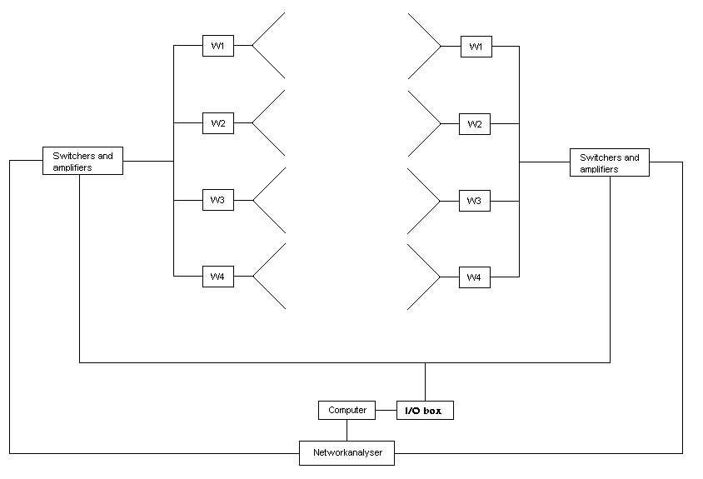
Figure 2.1 This figure shows an overview over the measurement equipment.

To measure the channel function between the antennas a network analyzer of the model Wiltron 360B is used. A computer that uses the software HP-VEE controls the I/O-box and the network analyzer.

2.2 Calibration
The calibration started with calibrating the network analyzer. The second step was to measure the mutual coupling matrices C_{m}, C_{b}. The transmitter was placed in an anechoic chamber and antenna element 1 and antenna element 2 was connected to the network analyzer. A S21 measurement was conducted and the result was C_{b}(1,2). A S21 measurement on a network analyzer means that the network analyzer measures the difference in amplitude and phase between its two ports. This continued until the whole matrix was measured. This procedure was repeated until both C_{b} and C_{m} was completely determined.
Depending of which antenna pair that is measured, different switches and different coaxial cables are being used. This made the calibration quite difficult. The approach used to solve this problem was to connect the coaxial cables that went to the transmitting antenna 1 and the coaxial cable from receiving antenna 1 directly to each other. Then the coaxial cable to transmitter antenna 1 and the coaxial cable to receiver antenna 2 were connected to each other and so on. By postulating that there is zero amplitude and phase change between the transmitting antennas 1 it is very easy to solve what the difference is in magnitude and phase for the rest of the antennas. When these differences were known they were compensated for in the software, HP-VEE.

2.3 Measurement environment
The measurement campaigns where conducted in several different environments and sometimes with different antenna configurations that will be described bellow. There were four different places for measurement A, B and C.

1.LOS (Line Of Sight) static channel, sending from A to B. The distance between the transmitter and the receiver was three meters.

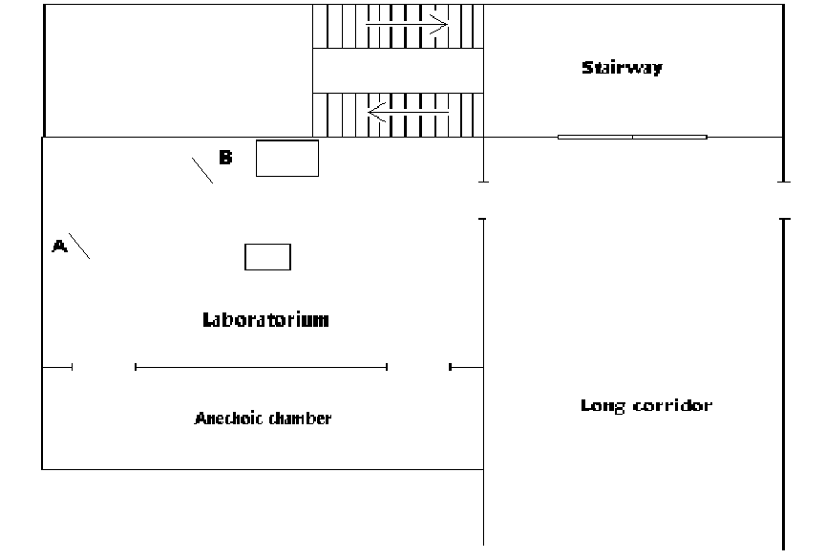

Figure 2.2 This figure shows an overview over the measurement environment for the LOS static channel.

2.NLOS (Non Line Of Sight) static channel, sending from A to C. The distance between the transmitter and the receiver was 15 meters.

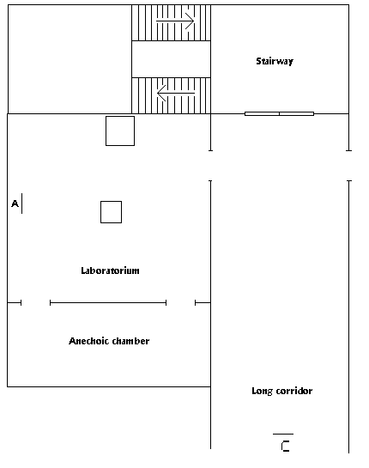
Figure 2.3 This figure shows an overview over the measurement environment for the NLOS static channel.
3.LOS non-static channel, sending from A to B. The distance between the transmitter and the receiver was three meters. To get independent samples from the fading distribution the antenna array with label B was moved around in the corridor. One H matrix measurement was made and then the B array was moved 1/8 of a wavelength straight back and the H matrix were measured once again. The B array was moved 30 times straight back before it was moved one wavelength to the side and then it was moved forward again 30 times before it again was moved one wavelength to the side and again was moved 30 times back and so on.

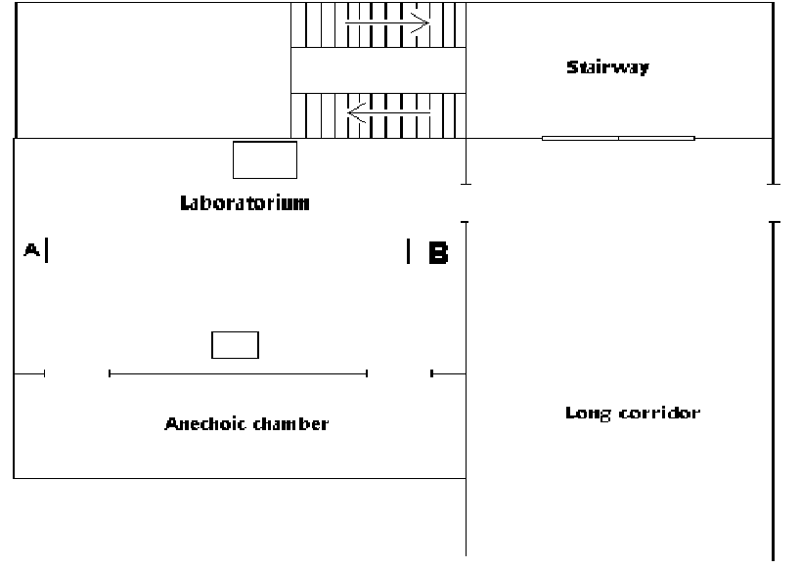

Figure 2.4 This figure shows an overview over the measurement environment for the LOS non-static channel.

4.NLOS (Non Line Of Sight) non-static channel, sending from A to D. The distance between the transmitter and the receiver was 15 meters. To get independent samples from the fading distribution the antenna array with label D was moved around in the corridor. One H matrix measurement was made and then the D array was moved 1/8 of a wavelength straight back and the H matrix were measured once again. The D array was moved 30 times straight back before it was moved one wavelength to the side and then it was moved forward again 30 times before it again was moved one wavelength to the side and again was moved 30 times back and so on.

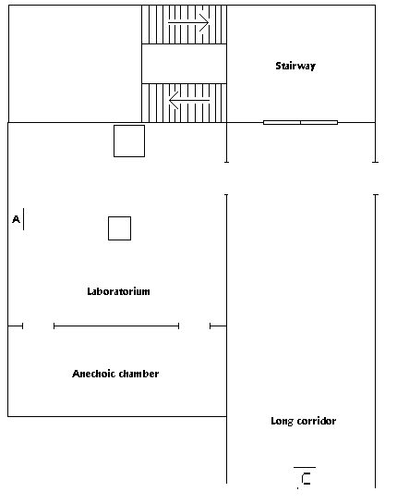

Figure 2.5 This figure shows an overview over the measurement environment for the NLOS non-static channel.

2.3.1 Description of the measurement locations
A, The array stands on a desk 130 cm above the floor and 50 cm from the wall.
B, The array stands on a table 130 cm above the floor. Behind the array is a large steel cabinet 40 cm away.
C, The array stands on a table 130 cm above the floor.
D, The array stands on a table 130 cm above the floor.

2.4 Antenna array configurations
Depending on the environment there were a few different antenna configurations that was used.
•Linear array, vertically polarized. The interelement distance was λ/2. See Figure 2.6.
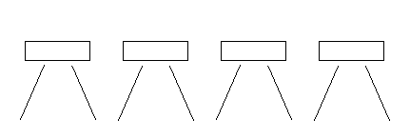
Figure 2.6 This figure shows a linear array with the interelement distance of λ/2

• Linear array cross-polarized. The only difference is that the first and third antenna was rotated 90° so they were polarized linearly vertically and horizontally.

•Circular array vertically polarized. The diameter of the circle was 3λ/2. See Figure 2.7.

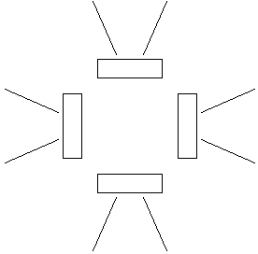

Figure 2.7 This figure shows a circular array with a diameter of 3λ/2

2.5 The retrodirective antenna measurements
The retrodirective antenna has a quite simple construction. It was the same kind of antennas as in the arrays. The retro antenna has two receiving antennas and two transmitting antennas and two individual amplifiers that amplifies about 15 dB at 1.8 GHz

There were three different measurements made.

1, NLOS with the retrodirective antenna stationed so that it enhances the multipath propagation in the channel. The array has two elements horizontally polarized and two elements vertically polarized. See Figure 2.8.

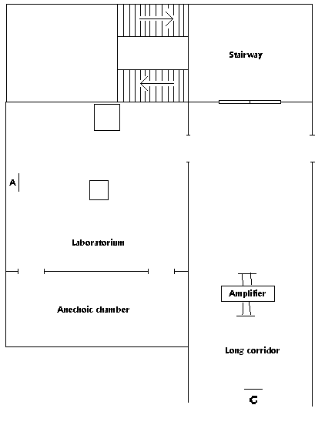
Figure 2.8 This figure shows an overview over the NLOS measurement environment when the retrodirective antenna is used to enhance the multipath propagation in the channel

2. NLOS with the retrodirective antenna stationed so that it helps the signal get around corners in a building. The array has two elements horizontally polarized and two elements vertically polarized. See Figure 2.9.

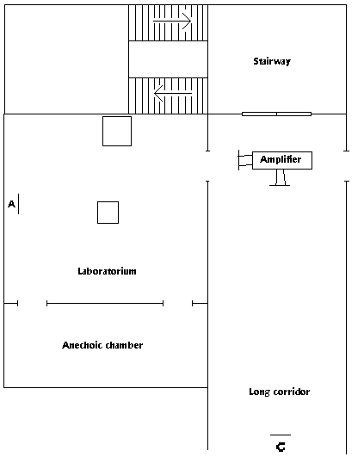
Figure 2.9 This figure shows an overview over the NLOS measurement environment when the retrodirective antenna is used to help the signal get around corners in a building.

3. LOS with the retrodirective antenna stationed so that it increases the multipath propagation in the channel. In this measurement the array has all of its elements vertically polarized. The retrodirective antenna had here only one receiving and transmitting antenna.

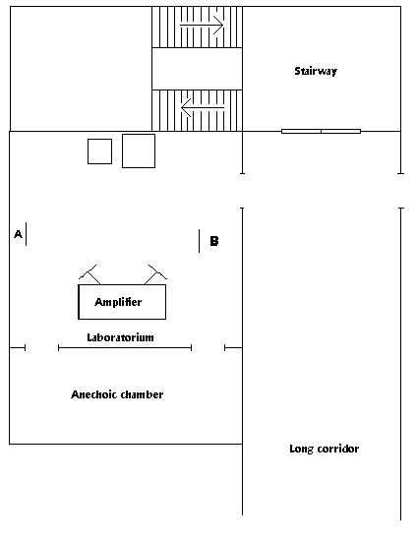

Figure 2.10 This figure shows an overview over the LOS measurement environment when the retrodirective antenna is used to enhance the multipath propagation in the channel

Results of the measurements in a static channel
First a few measurements that verifies the assumptions in section 1.2 will be performed. I.e. that the channel has a very long coherence-time and that it is frequency-flat. Then two measurements in a non-static channel will be made and finally a few measurements with a retrodirective antenna will be made. After these measurements it should be possible to answer the questions in the introduction.

3.1 Line of sight measurement with a linear array with all vertical polarization
Here the channel is between the points A=>B in fig. 2.1. The signal-and-noise-to-noise ((S+N)/N) ratio is 18dB.

Figure 3.1

Note that in Figure 3.1 the eigenvalues of the channel is approximately constant for the whole measurement time, 3500 seconds.
Figure 3.1b

Figure 3.1b shows the amplitude of four different channels for the first 140 samples and it can be seen that the received power is quite constant.

Figure 3.2

Figure 3.2 shows a histogram over the two largest eigenvalues both when compensated for mutual coupling and when it is neglected. It is shown that the distance is less between the two largest eigenvalues when mutual coupling have been compensated for, using the C_{m} and C_{b} matrices in section 1.4. The larger distance between eigenvalues should give a higher capacity when the mutual coupling is removed in reference to when the mutual coupling is neglected if the channel is unknown to the transmitter.

The capacity is calculated for three different input (transmit) power distributions. That is Uniform power distribution, the Waterfilling technique and beam forming is used. In addition to the above three cases the capacity when the mutual coupling effect has been compensated for has also been calculated for each power input distribution, as described in section 1.4.

Figure 3.3

From figure 3.3 it is confirmed that the capacity is higher when mutual coupling is compensated for and that the beam forming technique is an optimal power allocation technique up to a SNR value of about 0dB. The fact that there is a large difference in capacity for the Waterfilling technique and the Uniform Power distribution technique confirms that power is lost into modes with small gain (small eigenvalues) since $λ_{1}\text{>>}λ_{2}>λ_{3}>λ_{4}$ in a LOS-channel.

Figure 3.4

Figure 3.4 is a specific plot over the probability that beam forming achieves optimal capacity as a function of SNR, I.e. $\text{Pr}\left(\frac{1}{λ_{2}}−\frac{1}{λ_{1}}≥\frac{P_{T}}{σ^{2}}\right)$. Here it is possible to see that if the mutual coupling is not compensated for the optimal capacity is achieved up to 2dB in SNR.

3.2 Line of sight linear array with two elements horizontally polarized
This section presents results from measurements between points A and B in Figure 2.2 but two antenna elements are rotated so that they are horizontally polarized to increase the polarization diversity. The antenna pair with the best (S+N)/N is 20dB and the worst is about 8dB and this occur between horizontal=>vertical antennas.

The measurements in this section should lead to almost the same results as in section 3.1. This is because the channel is similar but there is a little more scattering because of the two antenna elements that are of another polarization.

Figure 3.5

In figure 3.5 it is shown that all eigenvalues except the largest has increased some, this is because the elements with orthogonal polarization more easily detects scattered signals, which are circular polarized. With these results it is possible to predict that this channel will have a greater capacity and that Uniform distribution will work poorly but not as bad as in section 3.1.

Figure 3.6

From Figure 3.6 it is possible to observe that contrary to the results in section 3.1 the distance between the largest and second largest eigenvalue in the matrix H*H’ is larger when the mutual coupling is not compensated for! This implies that the capacity will be greater when the mutual coupling is not compensated for.

Figure 3.7

Figure 3.7 confirms that the mutual coupling decreases the capacity but also that the total capacity is higher than for the measurement in section 3.1.

Figure 3.8

From figure 3.8 it can be seen that when beamforming gives optimal capacity for SNR values up to –6dB if the mutual coupling is neglected, as in eq(13). In figure 3.1 the slopes of the curves are not as steep for the two cases as they are here. That is because in this case the eigenvalues are concentrated around their mean values. See Figure 3.2 and 3.6 and observe that the peaks are equally tall and steep in figure 3.6 but not in figure 3.2.

3.3 LOS circular array with all elements vertically polarized
In this LOS measurement the channel is between points A and B in Figure 2.2 and a circular array is used at both ends. The channel with the greatest (S+N)/N is 18dB and the least is about 5dB. The lowest (S+N)/N value corresponds to the channel between two antennas pointing at opposite direction

Figure 3.9

If a comparison is made between figure 3.5 and 3.9 it can be observed that the largest eigenvalue is the same but in 3.9 the second greatest eigenvalue has decreased and the two least great eigenvalues has increased. Since maximum capacity is achieved when all the eigenvalues is equal it is uncertain if the capacity has increased or decreased compared with measurement 2 but Uniform power distribution should work better here than in measurement 2.

Figure 3.10

Figure 3.10 is similar to figure 3.6 and of the same reasons capacity will decrease if mutual coupling is compensated for.

Figure 3.11

Figure 3.11 confirm the hypothesis above and it can be observed that mutual coupling decreases the capacity and that Uniform power distribution achieves a greater capacity then in measurement 2.

Figure 3.12

From figure 3.12 it is evident that beamforming achieves maximum capacity if SNR is less then –3 dB.

3.4 NLOS linear array with all elements in vertical polarization.
In this measurement the arrays are linear and all elements are vertically polarized and the transmitter is in the corridor at point D in figure 2.1 and the receiver is at point A. The (S+N)/N=25dB in the best channel and about 12dB in the worst.

Figure 3.13

In figure 3.13 it is observed that the largest eigenvalue has decreased while the other eigenvalues has increased if a comparison is made with the line of sight case in Figure 3.9. This should yield an improvement in capacity since the sum of all eigenvalues is 16 and the more evenly spread there are the larger is the capacity.

The interested reader can look in appendix A at figure 5.1 that shows a plot over the two greatest eigenvalues with and without mutual coupling and as expected the mutual coupling increases the distance between the largest and second largest eigenvalues which makes the capacity decrease.

Figure 3.14

In Figure 3.14 it is observable that there is not much difference in capacity when Waterfilling is used compared to Uniform power distribution and that is because there are many modes active and equally strong. See section 1.4 for description of the concept of modes in a channel.

Figure 3.14

In Figure 3.1 it is shown that beamforming achieves optimal capacity when SNR is less than –8dB when mutual coupling is not compensated for.

3.5 LOS frequency sweep with linear array and vertical polarization.
In this measurement a sweep in frequency is made for every antenna pair, the sweep is from 1775->1825MHz.

Figure 3.15

Figure 3.15 shows four different channels that have been selected because they are representative for the channel. The coherence bandwith at correlation 0.9 is calculated to 3 MHz.

3.6 NLOS frequency sweep with linear array and vertical polarization.
In this measurement a sweep in frequency is made for every antenna pair, the sweep is from 1775->1825MHz.

Figure 3.16

Figure 3.16 shows four different channels that have been selected because they are representative for the channel. The coherence bandwith is calculated to 1.5MHz.

3.7 Conclusions of measurements in static channel
• The coherence-time of the channel is very long since it is not possible to see any significant difference in the eigenvalues of the channels over the almost one hour measurements made above.

•The channel has a coherence bandwidth of at least 1 MHz, this means that if the transmissions is more narrowband than this, the fading can be described as a complex number. Because of the large bandwith there should be possible to perform OFDM modulation to increase the capacity.

This also means that the assumptions made in section 1.2 are correct. There is flat fading in the channels and therefore it is possible to describe the fading with a complex number. Further more that the coherence time of the channel is longer then it takes to transmit a packet of information.

•The mutual coupling can increase the capacity if the channel is LOS. In a LOS channel there is little scattering and the channel matrix is of low rank with a high condition number therefore one eigenvalue will be very large and the rest small. In this scenario the effects of mutual coupling increases the capacity.

•If there is a NLOS channel with much scattering and equally spread eigenvalues then the mutual coupling effect will decrease the capacity. This is because the effect of the mutual coupling will increase the distance between the eigenvalues.

Results of the measurements in a non-static channel

3.8 LOS linear array and vertical polarization
In this measurement was the (S+N)/N=28dB.

To get independent samples from the fading distribution the antenna array with label B was moved around in the corridor. One H matrix measurement was measured and then the B array was moved 1/8 of a wavelength straight back and the H matrix were measured once again. The B array was moved 30 times straight back before it was moved one wavelength to the side and then it was moved forward again 30 times before it again was moved one wavelength to the side and again was moved 30 times back and so on.

Figure 3.17

Figure 3.18

Figure 3.17 shows the eigenvalues of the channel and 3.18 shows the amplitude of the (normalized) received power from four different antennas. It is shown that although the power of the individual antennas varies in amplitude the eigenvalues of the H matrix are quite constant. This is because the sums of the different amplitudes are almost constant. Compare with figure 3.1b where there are no fading dips in the received power.

Figure 3.18b

In figure 3.18b a histogram of the (normalized) received power has been made to estimate the PDF. A Nakagami m distribution has been adapted to fit the PDF. The two methods presented in section 1.2.5 have been used to estimate the m-parameter and it is easily seen that there is not much difference in the results. By assuming that m = 6.5 and by using eq(5) it is possible to estimate the K parameter in Rice to 11.5.

Figure 3.19

Figure 3.20

From figure 3.19 and 3.20 we can draw the same conclusion as from the measurements in section 3.1 that the mutual coupling increases the capacity in a LOS case. The second conclusion is that a CSI is very valuable for maximizing the capacity, in this measurement the capacity has improved 150%!

Figure 3.21

There should be no surprise that figure 3.21 is similar to figure 3.3
Figure 3.22

Figure 3.22 is quite similar to figure 3.4 but figure 3.22 is not as steep and this is because the movements of the array that makes the H-matrix not as static as in figure 3.4.

3.9 NLOS linear array and vertical polarization
In this measurement was the (S+N)/N=13dB and constant for all channels.

Figure 3.23

In figure 3.23 it is shown how the eigenvalues varies when the array is moved.

Figure 3.24

Figure 3.24 shows the received amplitude for four different antennas. The fading dips in the individual antenna elements can be easily seen.

Figure 3.25

Figure 3.25 show the fading dips in the capacity. It can be seen that the capacity is always greater then in the LOS case in section 3.8.
Figure3.26

Figure 3.26 shows a histogram of the amplitude and phase of the (normalized) received power. Since the Nakagami 1 distribution equals the Rayleigh distribution the conclusion that for the NLOS situation the fading is almost Rayleigh distributed. By assuming that m = 1.05 and by using eq(5) it is possible to estimate the K parameter in Rice to 0.3.

Figure 3.27

When comparing Figure 3.27 with 3.21 it is evident that the NLOS channel has a greater capacity then in the LOS case and that the improvement in capacity with the Waterfilling technique is not as large as in the LOS case. Considering this it is possible to draw the conclusion that CSI is more important in a LOS case than in a NLOS case.

Figure 3.28

From figure 3.27 and 3.28 it is easily realized that beamforming gives a very bad power distribution for the NLOS situation. This is because there is no direct beam from the transmitter to the receiver, which makes it difficult to know which way to direct the beams.

It should also be noted that the two cases in Figure 3.28 and in Figure 3.14 are much more similar in the NLOS case than in LOS.

3.10 Conclusions of measurements in a non-static channel
•The use of CSI is more important when there is a low SNR value or if the channel is a LOS channel. This is also valid if there is a LOS channel with poor SNR-value.
•Beamforming could be a good power distribution if there is a very noisy channel.
•Both the ML and the Momentum method give good approximations of the Nakagami m-parameter. Because of the slightly less complex algorithm the Momentum method is a better choice. The LOS channel has a Nakagami m parameter between 6.39 and 6.62. The NLOS channel is almost Rayleigh distributed with a Nakagami m parameter between 1.04 and 1.05.
•Phase is uniformly distributed in NLOS-channel.
•Waterfilling gives the optimal power allocation at all times.

3.11 Measurement with retrodirective antenna in LOS non-static channel
In the first measurement was the (S+N)/N=29dB. Both arrays are linear and with vertical polarization.

Figure 3.29

The retrodirective antenna received and transmitted the signal in the same polarization. The eigenvalues are plotted as function of measurement in figure 3.29.

Figure 3.30

In the next measurement setup the retrodirective antenna receives in vertical polarization and transmits in horizontal polarization (this is labeled “Cross-polarized antenna” in Figure 3.30). In figure 3.30 the eigenvalues are plotted as function of measurement.

It is quite difficult to see from the eigenvalue plot if the retrodirective antenna makes any significant difference there for the capacity is instead plotted as function of the SNR in figure 3.31 below. The legend ”Cross” means that it receives and transmits in different polarization, “vertical” means that it receives and transmits in same polarization and “no antenna” is a channel without any retrodirective antenna.

Figure 3.31

It is easy to see in figure 3.31 that the retrodirectiv antenna that receives and transmits in vertical polarization gives the greatest gain in capacity. In figure 3.32 it is shown explicitly the higher SNR values and that there is a gain of 1.5 dB in SNR for Waterfilling and Uniform power distribution.

Figure 3.32

From figure 3.31 and 3.32 it is also evident that the retrodirectiv antenna does not increase but decrease the capacity when beamforming is used. This should not be a surprise since beamforming does not make use of scattering when transmitting and then the increased scattering decreases the capacity.

3.12 Measurement with retrodirective antenna in NLOS case in a static channel
In these measurements the (S+N)/N varies between 20dB to 10dB. The transmitting and receiving antenna arrays were linear arrays with two elements vertically polarized and two elements horizontally polarized.

The first setup was to put a retrodirectiv antenna in the middle of the channel (see Figure 2.8). This retro directive antenna has two receiving antennas and two transmitting antennas. One of the receiving antennas is vertically polarized and the other is horizontally polarized. The one with a vertical polarization sends the signal to an antenna that transmits the signal in a horizontal polarization. The receiving antenna with horizontally polarization sends the signal to a transmitting antenna, which transmits in a vertical polarization.

It is showed in figure 3.33 (legend “linear crossed” refers to this setup) that this makes little difference in capacity. In figure 3.33 the capacity has been calculated for Waterfilling but the gain in capacity is the same for Uniform power allocation (not shown).

The next setup was to make the retrodirectiv antenna help the signals around corners. See section 2.9 for a further description. Two different circular retrodirectiv antennas were used.

The first circular retro directive antenna has two receiving antennas and two transmitting antennas. One of the receiving antennas is vertically polarized and the other is horizontally polarized. The one with a vertical polarization sends the signal to an antenna that transmits the signal in a horizontal polarization. The receiving antenna with horizontally polarization sends the signal to a transmitting antenna, which transmits in a vertical polarization. This setup is labeled “Circular crossed” in Figure 3.33

The other circular retro directive antenna that was used work in a similar way but both the receiving antennas were vertically polarized and both the transmitting antennas were horizontally polarized. This setup is labeled “Circular all vertical” in Figure 3.33

Figure 3.33

From figure 3.33 it is seen that a retrodirective antenna can improve the capacity when the signal is helped to go around corners. The increase in capacity is equal to about 1,5dB in SNR, when the SNR is higher then 5dB.

3.13 Conclusion of measurements with retrodirective in a non-static channel
•In a LOS scenario it is possible too improve the scattering with a retrodirective antenna.
•When there is a NLOS scenario the retrodirective antenna does not improve the scattering but it is possible to increase the capacity by helping the signal get around corners in a building.
•There is no use to have a retro directive antenna when beamforming is used. This is because the retrodirective antenna increases the scattering, which is not good when beamforming is used.

Conclusions of MIMO measurements

4.1 When is CSI most usefulness at the transmitter?
Performance of a MIMO system when using CSI and when CSI is not available has been compared and the conclusion is that when there is a LOS channel the CSI is very useful and also when there is a noisy channel (low SNR). This is because when there is no CSI available at the transmitter it transmits with the same amount of energy from all antennas and when there is a lot of noise in the channel or a NLOS channel there is a good chance that the signals different multipath gets independent fading. Independently faded channels are optimal for MIMO channels and then there is no reason to transmit more power from one antenna element than from others.

The CSI that are important to have are the noise variance at the receiver and the eigenvalues and eigenvectors of the H matrix and there is important to update this information on a shorter interval then the coherence-time of the channel. With this information the transmitter can use the Waterfilling technique (see section 1.3.4) to always transmit in an optimal way.

When there is a LOS channel beamforming works quite good and this is because the receiver and transmitter can “look” at each other in a way that is not possible in a NLOS scenario. Also there is little chance that the channels are independently faded in a LOS scenario.

4.2 What are the effects of mutual coupling at the antenna arrays?
The mutual coupling can increase the capacity if there is a LOS channel. In a LOS channel there is little scattering and the channel matrix is of low rank with a high condition number therefore one eigenvalue will be very large and the rest small. In this scenario the effects of mutual coupling increases the capacity.

If there is a NLOS channel with much scattering and equally spread eigenvalues then the mutual coupling effect will decrease the capacity. This is because the effect of the mutual coupling will increase the distance between the eigenvalues.

In summary, the effects of mutual coupling increases the capacity if there is a very clean, LOS, channel otherwise it will decrease the capacity.

4.3 How useful are the Nakagami m distribution?
The Nakagami m distribution has been used in this thesis to estimate the PDF of the fading in a channel. The Nakagami m distribution needs the variance of the channel coefficients and a value of the m parameter. The variance can easily be estimated from a set of samples, and in section 1.2.5 two different methods has been presented that both has proven to been most useful in estimating the m parameter both when the channel is almost Rayleigh distributed (NLOS) and when there is very little multipath propagation in the channel (LOS).

4.4 When can a retrodirective antenna be useful in a MIMO channel?
Measurements have shown that in a LOS channel when MIMO systems works poorly a retrodirective antenna can be used to increase the multipath propagation in the channel so that the capacity increases. It has also been shown that a retrodirectiv antenna can be useful to help the signal propagate around corners in a building.

Appendix A

Figure 5.1

Acknowledgement
I would like to thank my supervisors Mattias Wennström, Dhanesh G. Kurup and Anders Rydberg at the Signals and Systems Group at Uppsala University for all the help during the work with my master thesis.

References

[1] M. Nakagami, ”The m-distribution, a general formula of intensity distribution of rapid fading,” in Statistical Methods in Radio Wave Propagation, W.G Hooffman, Ed. Oxford, England: Pergamon, 1960.
[2] H. Suzuki, “A statistical model for urban radio channel model,” IEEE Trans. Common., vol. 25, pp.673-680, July 1977.
[3]H. Bölcskei, A. Paulraj ”Multiple-Input Multiple-Output (MIMO) Wireless Systems”, The Communications Handbook, 2nd ed., J. Gibson, Ed.
[4] C. Julian, B. Norman “Maximum-Likelihood Based Estimation of the Nakagami m Parameter”, Fellow IEEE, Commun letters, vol. 5 No 3 March 2001.
[5] F. Boixadera Espax, J. Boutros ”Capacity considerations for wireless MIMO channels,” http://www.com.enst.fr/publications/publi/MMT99_boixadera.ps. 2002-01-08.
[6] M.Wennström, M. Helin, T.Öberg”On the Optimality and Performance of Transmit and Receive Space Diversity in Rayleigh Fading Channels,” IEE Seminar on MIMO Systems, London Dec. 12, 2001.
[7] T.Svantesson, A. Ranheim ”Mutual coupling effects on the capacity of multielement antenna systems,” Acoustics, Speech, and Signal Processing, 2001. Proceedings. 2001 IEEE InternationalConference on , Volume: 4 , 2001. Page(s): 2485 -2488

